PTF Board:
President
Eden Green
Secretary:
Kayla Lentz
Treasurer:
Jennifer Kennedy
Administrative/Teacher Coord.:
Breyanna Frye -Green
volunteer
Coordinator:
Denise Williams
Fundraising Coord.
Kim Stovall
Hospitality Coord.:
Camela Caballero

Important Dates:
December 7th
PTF Meeting
December 8th-11th
Singing Christmas Tree:
Christmas Break:
December 15th -January 4th
Extended Christmas break
December 22nd- January 4th
Church at Argyle Christmas service
December 24th:

Very important: Mrs. Niya’s twos, Mrs. Vicky and Mrs. Paula’s
VPK Classes. Pay special attention to the Car Line changes for December 6th-11th. You will follow a different traffic pattern due to the Singing Christmas Tree.

Blessings to you and your family this special time of year. May the peace and love of Christ be ever present in your hearts and homes this Christmas season.

Sometimes as parents we must be reminded to keep our expectations in line with reality when it comes to our children. While we certainly want our children to know that the focus of Christmas should be on Christ, we should not be appalled when our children embrace the traditions associated with Christmas, such as presents and cookies, yet seem uninterested in the story of Christ’s birth. This does not mean that we should not continue to draw the focus of Christmas back to Christ and work on making the details of His birth and life on earth interesting, but we must embrace the fact that our children are just that: children. If we are to be in line with reality, we know that they will respond to Christmas like children. We can work joyfully on their growing and developing a relationship with Jesus, knowing that God has much work to do in their lives. Enjoy your little ones. Someday their wide-eyed wonder at the fun traditions of Christmas will turn to excitement and awe at the magnitude of Christ’s birth and what this day really means.
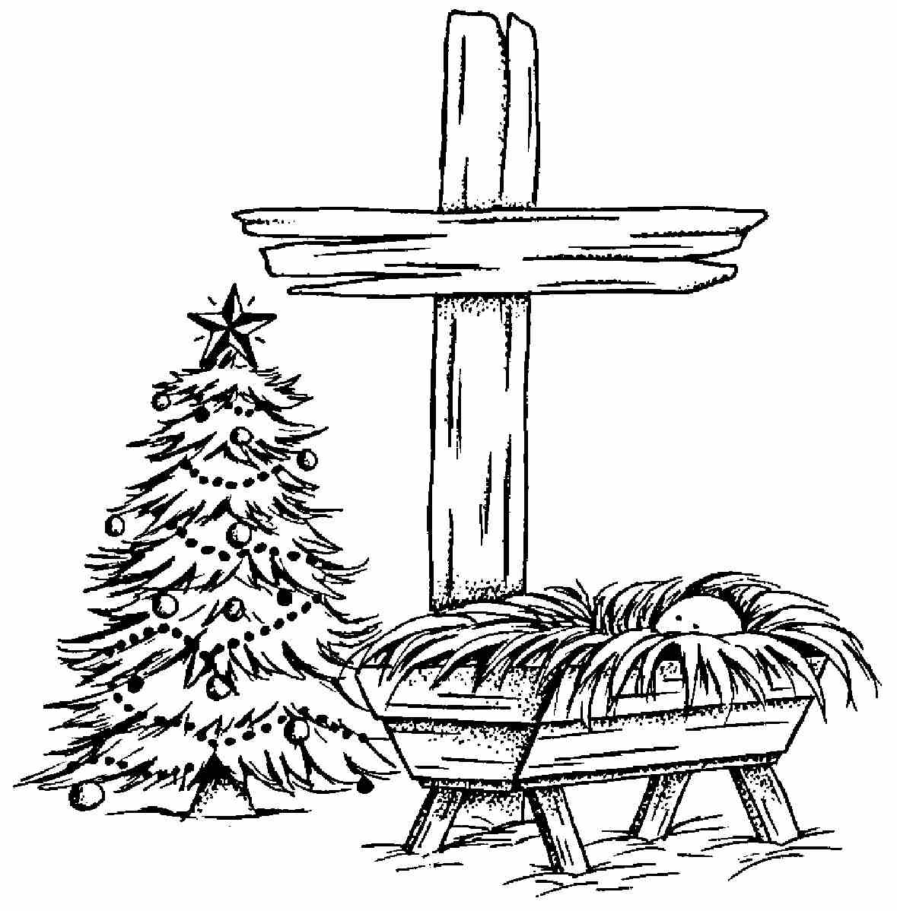
“When I was a child, I spoke as a child, I thought like a child and I reasoned like a child. When I became a man, I put away childish things.” I Cor. 13:11

One of the ways that we bring the true meaning of Christmas is by having a “Happy Birthday Jesus” party. Please check with your child’s teacher for the details of this event.

I have included a list of developmentally appropriate toys on the reverse side. It is so important to make sure that the toys we are gifting are beneficial and not detrimental to our children’s development.

The Church at Argyle will host a couple of events in which we’d love to have you partake. The Annual Argyle Outdoor Singing Christmas Tree is Wednesday– Saturday, December 9-12, at 8:00 pm each evening. The Tree has become an Argyle community tradition. It's a great way to invite your friends, neighbors and co-workers to enjoy both great music and the message of God's greatest gift to mankind – Jesus. Everything is free and everyone is welcome. We provide plenty of parking and comfortable seating. It is outdoors, so everyone should watch the weather reports and dress appropriately.

Please join our church family at 6:00pm on Christmas Eve for our Candlelight service. Everyone is welcome!

Thank you so much to those of you who have contributed to our food drive. We provided countless families with Thanksgiving meals. The food pantry at the church is still in need of replenishing after the Thanksgiving season so you are always welcome to contribute to the food pantry to be a part of ministering to the community through daily donations of food to those in need.

School will be closed from Wednesday, December 15th through Tuesday January 4th. Extended care is closed from December 22nd - January 4th. The entire school reopens on January 5th. Enjoy the holidays with your families!

Blessings in Christ,
Paula Chambers, Director

